
Hayling Island Horticultural Society
SUMMER SHOW 2021

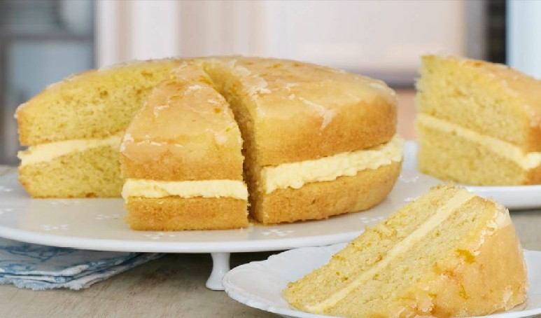
Orange Drizzle Cake
Ingredients
175g self raising flour
175g caster sugar
175g unsalted butter
3 eggs lightly beaten
1 teaspoon baking powder
Zest of 1 medium orange
Drizzle
Juice and zest of ½ medium orange
3 level tablespoons granulated sugar
Buttercream
100g sifted icing sugar
50g unsalted butter, softened
½ - 1 tablespoon orange juice
Method
Pre-heat the oven, 180º / 160º fan / Gas 4. Lightly grease and base line two 18cm (7”) loose bottomed sandwich tins.
Put the flour, sugar, butter, eggs, baking powder and zest of 1 orange into a bowl and mix to create a smooth batter.
Divide the batter evenly between the two tins, level with a spatula and bake in the
pre-heated oven for 20-25 minutes.
While the cake is baking make the orange drizzle syrup. Place the granulated sugar into a small bowl, add the juice and zest of ½ orange and mix together to create the syrup.
Once the cake is cooked remove from the oven and place the tins onto a cooling rack. Select the best cake for the top layer and spoon over the orange sugar syrup to create the drizzle. NB: You may not need all the syrup hence it is better to spoon over rather than pour. Leave to cool for 5 minutes, then remove from tins and place back onto the cooling rack.
For the buttercream sift the icing sugar into a bowl, add the butter and zest of ½ orange plus ½ -1 tablespoon of the juice, which should be added a little at a time to prevent the buttercream from becoming too runny. Beat well to create a stiff cream; add a dash more juice if needed until it is smooth and pliable.
Evenly spread the orange buttercream onto the cake that will form the bottom layer and place the drizzled layer on top.

